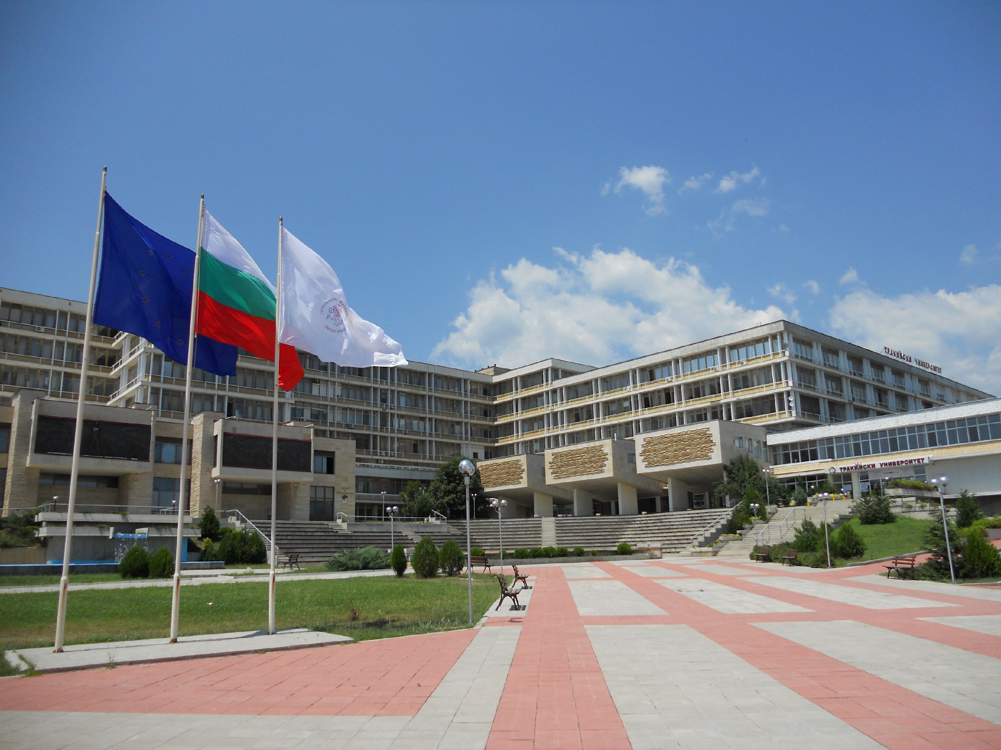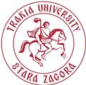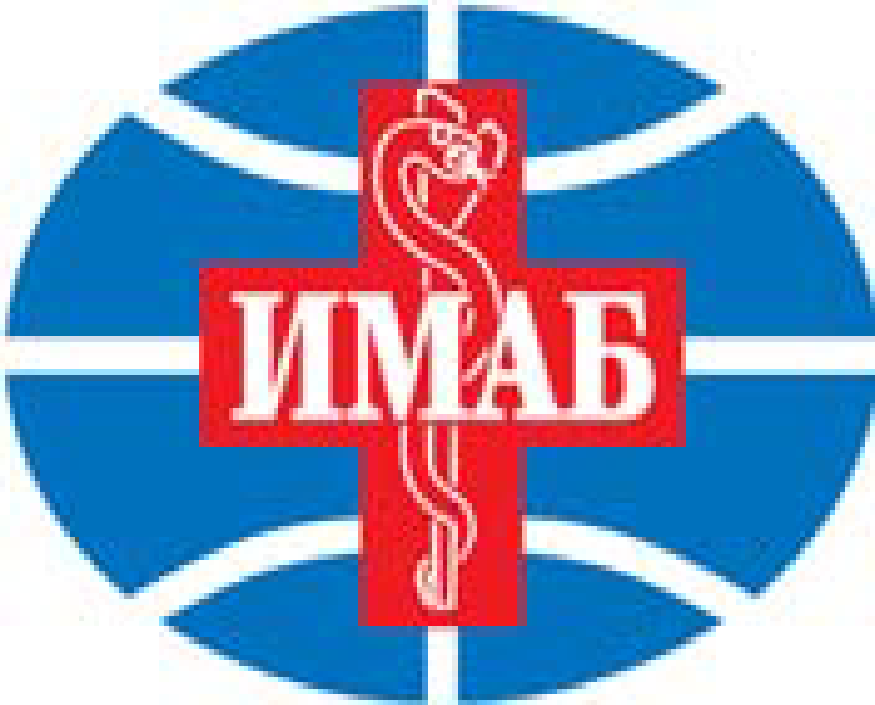

Joint Forum:
12th South-East European Conference
and
32st Annual Assembly of IMAB

20-23 October 2022
Medical Faculty, Trakia University of Stara Zagora, Bulgaria

Dear colleagues and friends of SEEC and IMAB,

Warmly welcome to Stara Zagora, the venue of the Joint Forum of 12-th SEEC and 32-st IMAB (Intl. Medical Association Bulgaria).

We, and the entire world, are going through a very hectic time, the Corona virus pandemics, which terrifically and permanently changes our daily life, plans and intentions. Now, as additional stagnation, we are facing the conflict in Ukraine.

After 30 years of exclusive performance of IMAB, mainly with the international annual meetings in Varna, Bulgaria, and 10 years of existence of SEEC, with annual forums in different countries in South-East Europe, we had to miss our 2020 meeting, due to the Corona virus, and the 10-th SEEC had to be canceled in Bratislava 2020, due to the pandemic lockdown.
We restarted our Joint Forum, 28-31 October 2021, when Plovdiv took over the responsibility to get-together colleagues and friends to continue the tradition of active scientific meetings of IMAB and SEEC, cultural events, productive round-tables and warm friendly atmosphere. We were rather happy to host in Plovdiv over 280 participants from Bulgaria and 7 foreign countries.

Now, it is time, 20-23 October 2022, to move the Joint Forum to Stara Zagora, Bulgaria, where the Trakia University, shall be our host.

However, and most probably, we must synchronize our meeting with the pandemic restrictions and therefore, our Joint event in 2022 could be again organized and realized in two options: with presentations in-person, and with presentations on-line. In addition, we firmly hope for a peaceful end in Ukraine.

Of course, we shall follow the order of our previous meetings, with sessions in four different sections:
Medicine, Dental Medicine, Organization and Control of Healthcare and a Round Table “Coronavirus, Global Pandemic and the Bulgarian Experience”.

The participants are specialists in medicine, dental medicine, pharmacy, health management, social medicine and biomedical sciences, and they shall present their expertise as plenary speakers (up to 20-minute lecture), oral presenters (up to 10 minutes), or with a poster, or as attending participants (listeners).

As already announced, we have two options and the Scientific Programme is divided into two major formats: in-person and online presentations.
Of course, in the meantime, until October 2022, if the situation around the world would be changed in a better way, we all shall be more than happy to organize and realize our Join Forum in-person, and Stara Zagora will be our friendly host.

We all are highly dedicated to our long-term (over 31 years for IMAB and over 11 years for SEEC) warm friendship, giving us the impulse of excellent relations, serious scientific contributions, active exchange of opinions and experience, happy cultural events and promising future activities in continuation of the Motto of IMAB and SEEC: Semper Eadem, Paratus et Fidelis !!!

Welcome to Stara Zagora and enjoy our time together, for the benefit of medical science, friend relations and future perspectives!

Co-Chairs of the Joint Forum SEEC+IMAB:
Dobri Yarkov, PhD, DSc Krassimir Metodiev, MD, PhD, DScmed
Rector of Trakia University, St.Zagora President of IMAB, Hon.Chair of SEEC

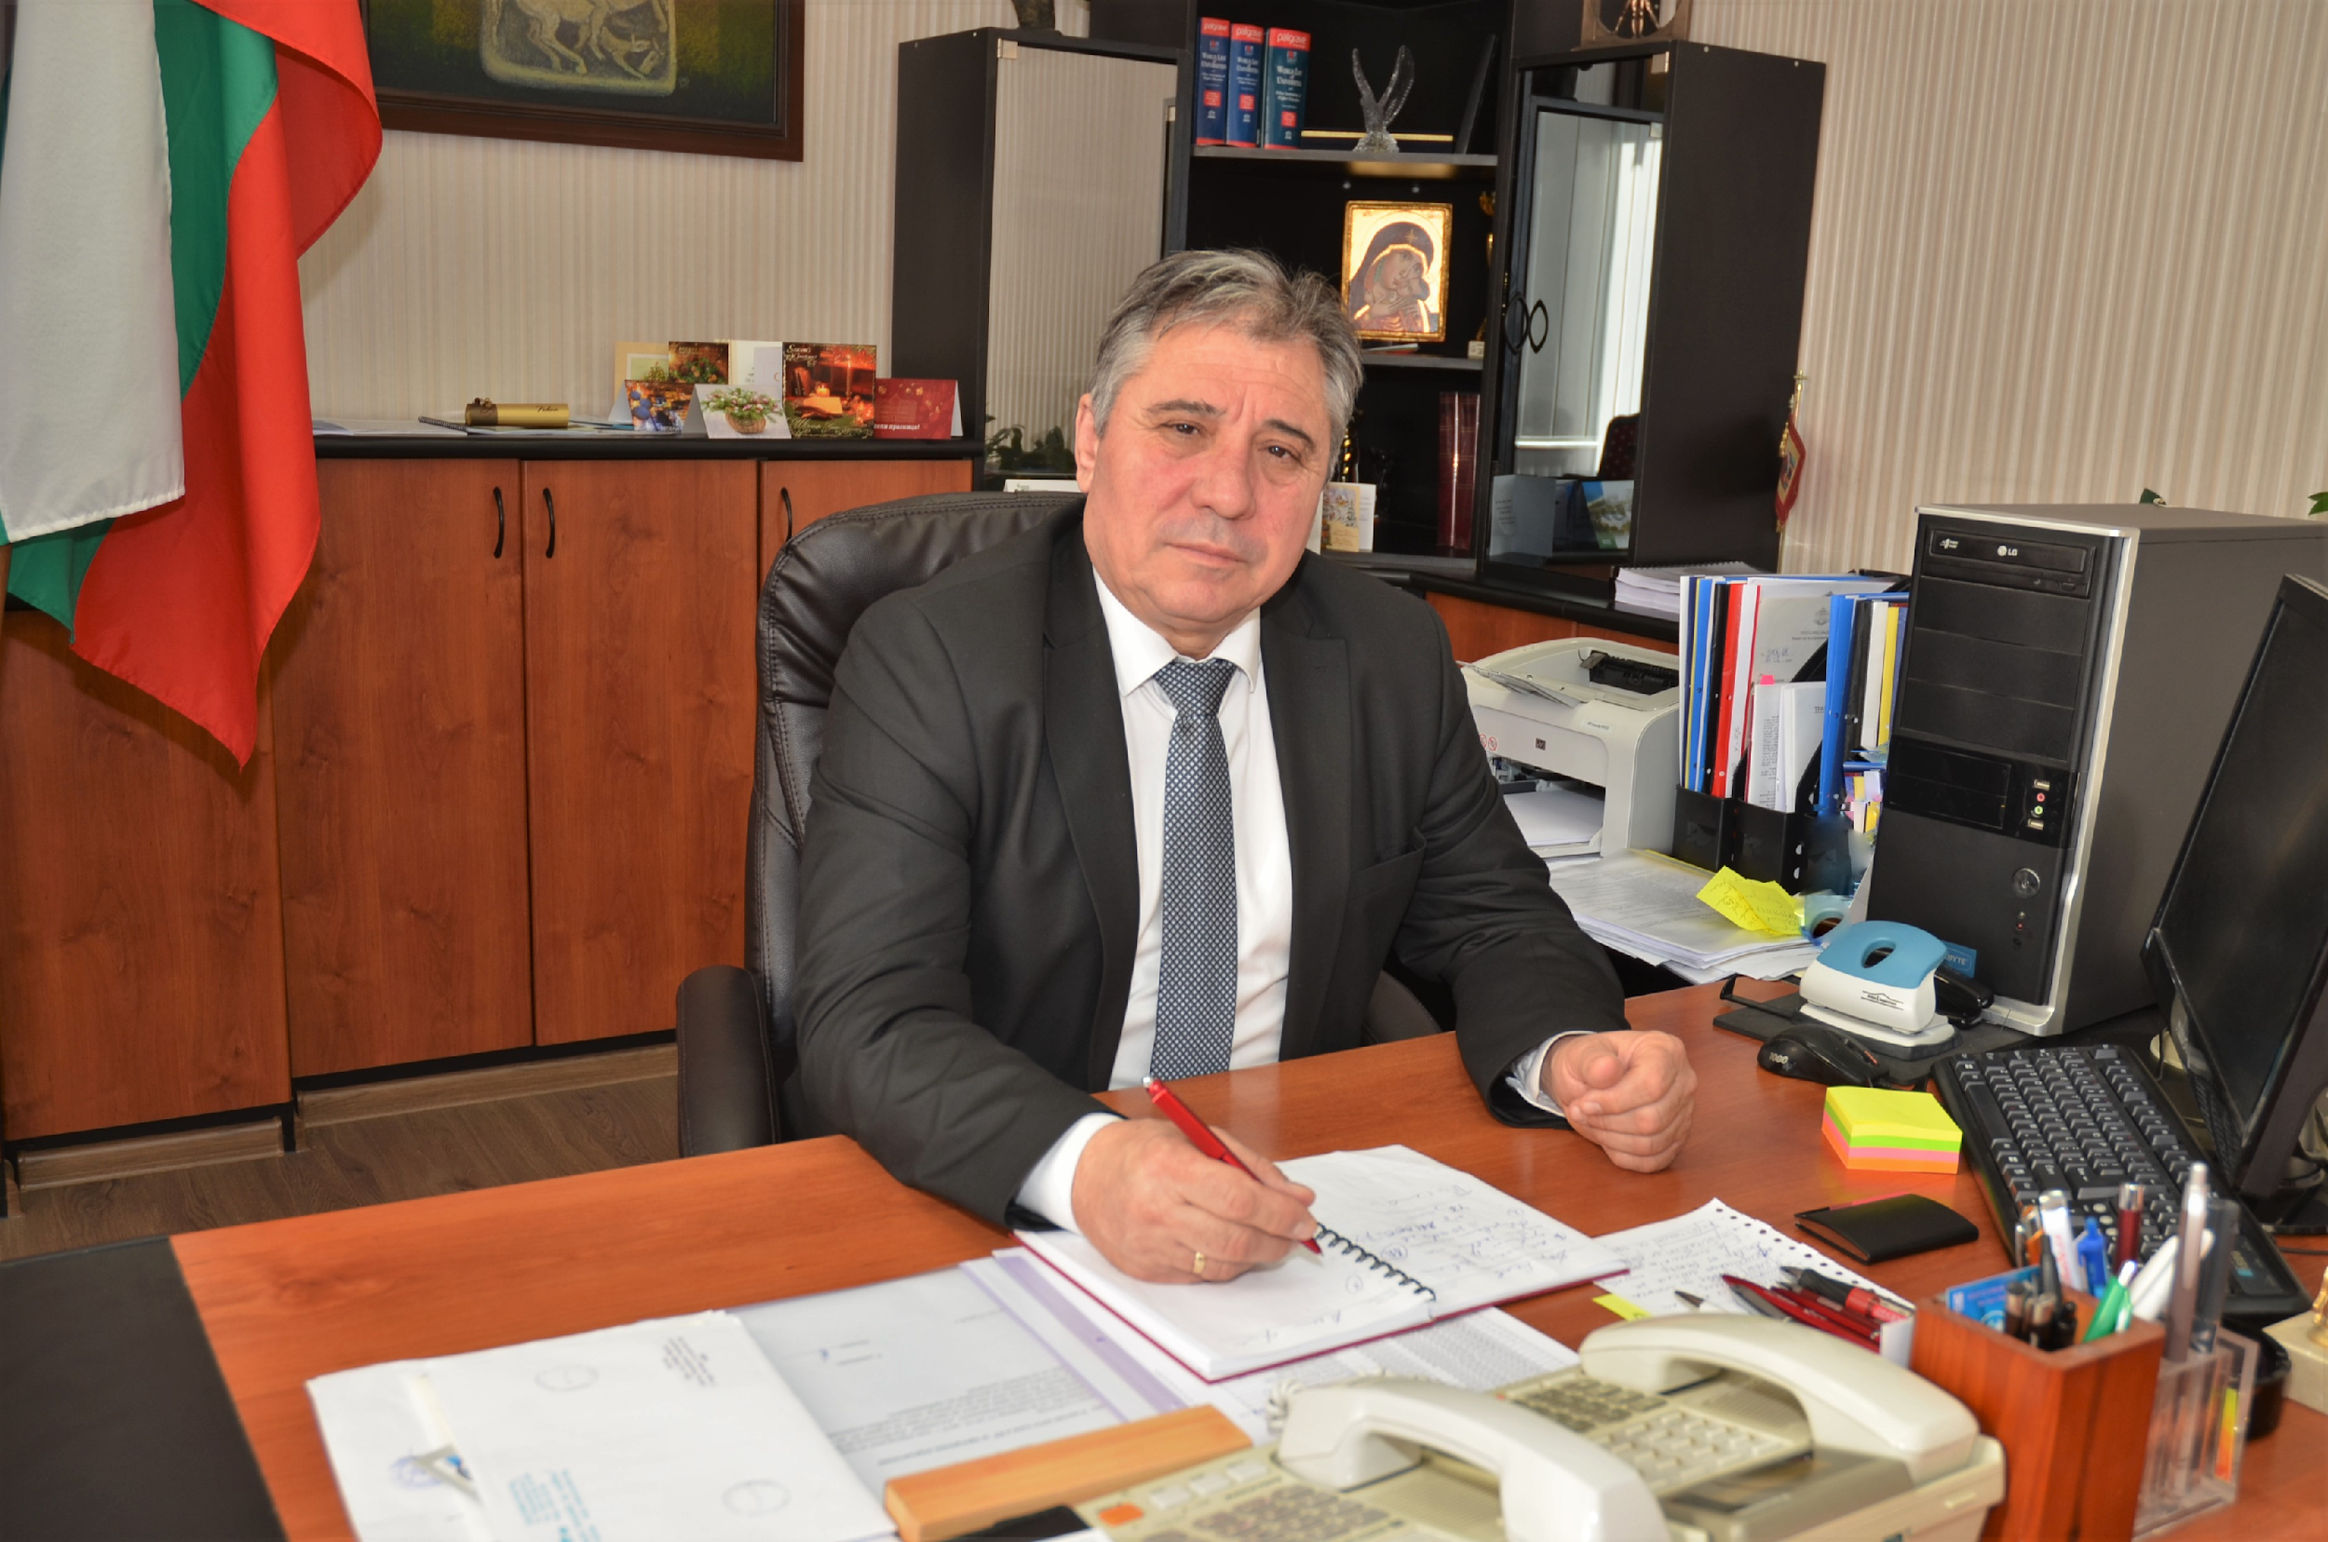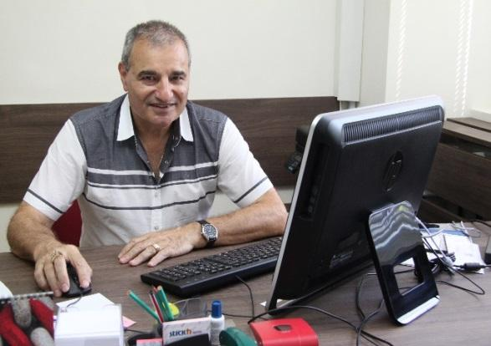

Please, kindly use our official e-mail for further contacts: seec.imab@trakia-uni.bg

